Samuel ahuno(sta2855)

The exponential family is a class of distributions that share a common formula(function). It includes the Bernoulli, beta distributions, Gaussian distributions etc.

Conceptually, there are all those distributions in the world. And a small number of them are labelled as exponential family because they can be expressed in a similar way. 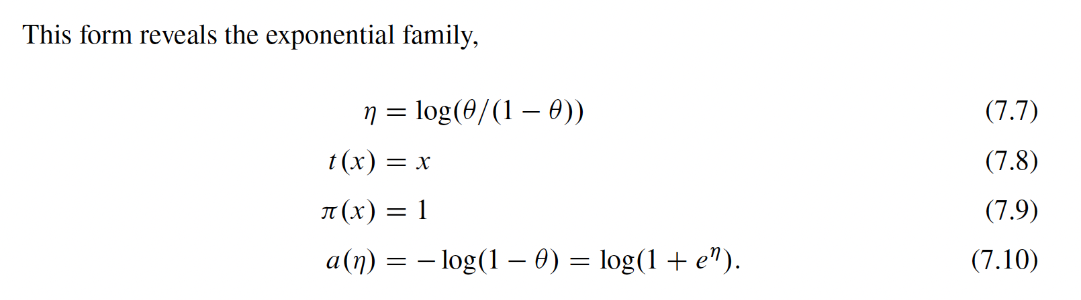

I was wondering how you get eqn 7.10

n = Log# – log(1 - #)

n – log# = -log(1 - #)